**What is AWS Artifact?**

AWS Artifact provides on-demand downloads of AWS security and compliance documents, such as AWS ISO certifications, Payment Card Industry (PCI), and Service Organization Control (SOC) reports. You can submit the security and compliance documents (also known as *audit artifacts*) to your auditors or regulators to demonstrate the security and compliance of the AWS infrastructure and services that you use. You can also use these documents as guidelines to evaluate your own cloud architecture and assess the effectiveness of your company's internal controls. AWS Artifact provides documents about AWS only. AWS customers are responsible for developing or obtaining documents that demonstrate the security and compliance of their companies. For more information, see [Shared Responsibility Model](http://aws.amazon.com/compliance/shared-responsibility-model/).

You can also use AWS Artifact to review, accept, and track the status of AWS agreements such as the Business Associate Addendum (BAA). A BAA typically is required for companies that are subject to the Health Insurance Portability and Accountability Act (HIPAA) to ensure that protected health information (PHI) is appropriately safeguarded. With AWS Artifact, you can accept agreements with AWS and designate AWS accounts that can legally process restricted information. You can accept an agreement on behalf of multiple accounts. To accept agreements for multiple accounts, use AWS Organizations to create an organization.

AWS Artifact is not a service you use to build a resource like an [EC2 instance](https://intellipaat.com/blog/what-is-amazon-ec2-in-aws/), a database, or [AWS VPC](https://intellipaat.com/blog/aws-vpc/), in contrast to other AWS services. Instead, you can access and download AWS security and compliance data as well as any online agreements through AWS Artifact, an on-demand platform.

Your go-to, central resource for compliance-related information that concerns you is AWS Artifact. It offers on-demand access to certain online agreements as well as security and compliance information from AWS.

The Service Organization Control (SOC) reports, Payment Card Industry (PCI) reports, and certifications from accrediting bodies across geographies and compliance verticals that vouch for the implementation and operational efficacy of AWS security controls are among the reports that are accessible in AWS Artifact.

The Business Associate Addendum (BAA) and the Nondisclosure Agreement are contracts that can be found in AWS Artifact (NDA).

You may show your auditors or regulators how secure and compliant your AWS infrastructure and services are by downloading audit artifacts from AWS Artifact.

## **History of AWS Artifact**

The official launch of AWS (Amazon Web Services) took place. 2007: More than 180,000 developers registered with AWS in 2007. 2010: Amazon.com’s retail web services were transferred to AWS in 2010, meaning that [Amazon.com](https://www.amazon.com/) is now powered by AWS. 2011 saw significant issues with AWS.

**Now its time to know about the history of AWS Artifact which is as follows:**

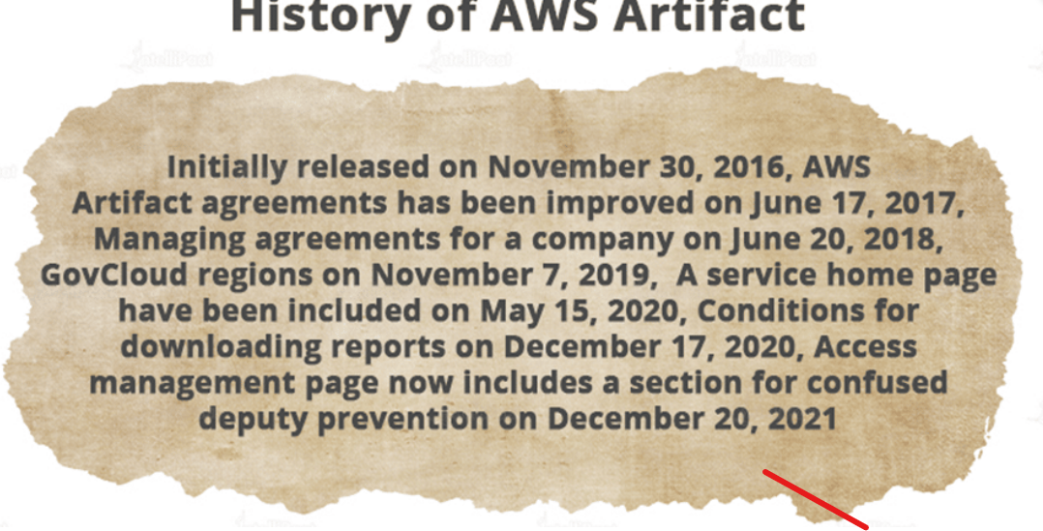

## **Need of AWS Artifacts**

All reports, or artifacts as they are known by AWS, are divided into two groups: public and confidential. All AWS accounts have access to public items.

Confidential artifacts need Amazon’s clearance and, in some situations, a non-disclosure agreement from the requesting client in order to be delivered.

An administrator with AWS Identity and Access Management capabilities can limit or distribute access to an item.

AWS is required by the shared responsibility model to secure compliance papers in the cloud, but if a user downloads an agreement, they are still responsible for protecting the downloaded file. A distinctive, trackable watermark is supplied with each downloaded artifact.

Each report’s description in AWS Artifact includes information about the applicable date ranges, geographies, and cloud services.

AWS Artifact Agreements, another element of the portal, allows users to examine, accept, and keep track of the status of a Business Associate Addendum (BAA) agreement.

If a business deals with protected health information and is subject to the Health Insurance Portability and Accountability Act, AWS normally demands that it comply with a BAA agreement.

Through the AWS Management Console, an AWS user can access AWS Artifact from anywhere at any time. The use of artifacts and artifact agreements is free of charge with AWS.

## **Benefits of AWS Artifacts**

AWS enables you to keep tabs on the resources used by your applications, accessibility, and stored data. Additionally, it offers identification and access control together with ongoing real-time security information monitoring.

No matter where the data is stored, it guarantees that the appropriate resources have appropriate, adequate access.

**Let’s discuss the benefits of AWS Artifacts which are very crucial for aws technology**

* AWS ISO certifications can be seen and downloaded.
* PCI and SOC reports can be seen and downloaded.
* For auditors and regulators, downloads are permissible as “audit artifact” submissions.
* Utilize papers to gauge how well your company’s controls are working.
* Use IAM policies and whitelisting to delegate permissions.

## **Application of AWS Artifact**

AWS makes it possible for businesses from various backgrounds to create complex applications. The primary applications can range from big data-driven analytical software to hyper-scale web applications. There are numerous ways for each business to profit in the middle.

* **Backup and storing**

Amazon offers inexpensive and highly practical cloud storage services. You can use a variety of storage options to fuel your business in addition to sending important data and system images to AWS for backup.

* **Big Data**

[Big Data](https://intellipaat.com/blog/what-is-big-data/) fuels [AI](https://intellipaat.com/blog/what-is-artificial-intelligence/), and AWS provides the infrastructure that will best support the development of the newest intelligent applications. Because they have scalable storage that can be quickly indexed and used at high frequency to run analytics, building data warehouses (or lakes) in AWS is simple.

* **Enterprise IT**

Enterprise IT projects can be implemented slowly for a variety of reasons, including the need to wait for supplies, implement servers, and navigate the bureaucracy.

By passing this, Amazon Cloud enables departments to create, test, and run auxiliary workloads in the cloud, accelerating the launch of projects.

* **Mobile, web, and social apps**

AWS was created primarily to support the introduction and scaling of web applications for mobile, SaaS, and e-commerce. Initially, Amazon servers could be used to set up and create new apps. They can now be constructed using sophisticated serverless platforms that do not need operating systems or related management.